An Environmental Perspective into New York’s Department of Building Permits

Pranav Behari Lal

Pranav.lal30@gmail.com

# Abstract

New York is an exciting city to live in but it also one of the densest cities in the world. The boom in the financial market has seen a massive influx of people over the last few decades. With such rapid urbanization comes a strain on the city to provide housing for all its citizens. This has led to the real estate to transform into a multi-billion-dollar industry. While this may have helped boost the economy, such large-scale construction would have had an impact on the city’s environment. In this study, I aim to study the construction in New York over the last 30 years and determine its impacts on Air Quality and Electricity and Water consumption. In the first half of the study, I focus on the temporal and spatial trends inherent in the construction of the city. Next, I focus on the impacts of the construction and demolition activities on the Air Quality in the 5 Boroughs of New York. Finally, I look at the Electricity and Water consumption in the City and identify the renovation activities that might have had an influence. Through this study, I am to highlight the policies that the city of New York has undertaken to curb environment degradation, and relate these findings back to the construction permits issued to see these policies in action, so to speak.

# 1. Methodologies and Datasets

In the first half of the study, I have analyzed the evolution of the construction scene in New York over the last 3 decades and across its 5 major Boroughs. The Department of Buildings requires that the construction industry file an application to the DOB with details of the construction job they would like to complete. This is the primary dataset for my study. Each record in the permit issuance dataset represents the life cycle of one permit for one work type. I have correlated the increase in permits being filed with the population of New York. This has been done to support my claim that the trends in the permit dataset can be used as a reasonable and justifiable proxy to the trends of the actual population in the city. Various statistical tests were performed to test this hypothesis, the results of which are explored in Section 3. Next, I have studied the differences in construction activities in the 5 Boroughs. Construction permits in New York are split into 5 broad categories – New Building, Alteration Type I that refers to a major construction, Alteration Types II and II that refer to minor renovations, and Demolition activities. By studying the correlation between a Borough and its construction permit patterns, I hope to highlight the successes or failures of the Boroughs in some of the environmental impacts that I study next.

These findings set a platform for the main focus of my study, which is to see the impacts of urbanization on the environment. Specifically, I have focused on the Air Quality, and Electricity and Water consumptions in New York. The United States Environmental Protection Agency provides access to outdoor air quality data collected from all states and counties across the United States. Annual summaries of this Air Quality were used, with a subset for the state of New York and its 5 major Boroughs. A regression analysis was performed to study the impact of major construction and demolition activities on the Air Quality. Finally, Electricity and Water consumption data from the NYC OpenData portal was used to understand the evolution of consumption habits over time. Tying these results back to my primary permit issuance dataset, I have identified the policies that the City has put in place to aid with the consumption. I have looked for the prevalence of the policy implementations in the permit dataset to highlight their successes.

# 2. Understanding the Permit Issuance Patterns

The Department of Buildings requires that the construction industry file an application to the DOB with details of the construction job they would like to complete. Each record in the permit issuance dataset represents the life cycle of one permit for one work type. This Section studies the trends prevalent in the permit issuance dataset. I begin by correlating the permit dataset with the increasing population in New York. The Population in New York has been growing exponentially over the last couple of decades. This same trend can also be seen in the number of work permits being filed at the DOB. While this increase can be attributed to changes in the system followed by the DOB, like e-filing, I am only interested in the trends and not the actual numbers. The hypothesis here is that an increase in the number of work permits is, at least in part, a by-product of the increase in population of the city. To put this hypothesis to test, I performed a Mann-Whitney-Wilcoxon Test to identify if the percentage increases in Population and the Number of Permits filed with the DOB follow the same distribution. The test was chosen because it does not make any assumption on the normality of our data. It was found that, at a 0.1 significance level, we can conclude that the two metrics do, indeed, follow an identical distribution. With this result, it is now possible to think of patterns in the permit dataset as a justifiable estimate of the true population trends. The increase in the number of permits filed with the DOB and, by extension, the increase in population in the city can be visualized as shown in Figure 2.1.



*Figure 2.1 – Number of permits filed with the DOB*

The primary types of application, aka job type, are: New Building, Demolition, and Alterations Type 1, 2, and 3. Each job type can have multiple work types, such as general construction, boiler, elevator, and plumbing with each work type receiving a separate permit. The dataset contains 60 predictor variables that I have placed into 3 broad categories. The first is location information of the property in question. This includes the Borough the building is located in, its street address and purpose of the building, that is, Residential or Commercial. The location data was primarily used to find trends within the 5 Boroughs of New York. It was found that Manhattan is the busiest of the 5 Boroughs, accounting for approximately 42% of the all the permits filed. The second category of information pertains to the actual construction. Here, the type of work is listed along with information on the date of filing and the status of the permit.

Figure 1.1 shows the distribution of the job types that are found in the dataset. Almost 60% of filings are for the A2 job type, an alteration work on a building that does not change its use of occupancy. A Chi-squared Test was performed to test the null hypothesis whether the Job Types are independent of Boroughs.



*Figure 2.2 – Permit Job Types by Borough*

With extremely low p-value in the above test, we can reject the Null Hypothesis and conclude that Borough and Job Type are strongly dependent on each other, that is, the Boroughs in New York has varying construction patters. New Building (NB), Alteration Type I (A1) and Demolition (DM) type jobs will be studied further in the Environmental Impacts of Construction section. The third category of information is Contact Information of the Owners of the property and the person who is filing the application. This section is not touched in my current analysis.

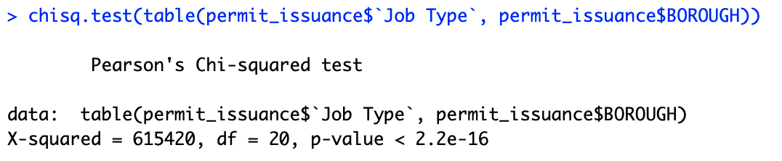

*Figure2.3 – Pearson’s Chi-squared Test*

In the following sections, I will be looking into the environmental impact that the increase in population has had, and attempt to relate these findings back to my primary permit issuance dataset. I begin by analyzing the constructions of new buildings and demolitions of existing buildings and quantify the ecological impacts of these activities. Finally, the Electricity and Water consumptions in New York are studied to identify the successes in City policies to reduce environmental impact.

# 3. Environmental Implications

## 3.1 Construction Phase

According to an independent research by construction blog Bimhow, the construction sector contributes to 23% of air pollution, 50% of the climatic change, 40% of drinking water pollution, and 50% of landfill wastes. In my study, I have chosen to focus on the impacts of construction on the air quality in New York city, and to find the correlations between the constructions permits and the Air Quality Index in New York.

To begin, I have taken a subset of the initial dataset to include only the New Building (‘NB’), Alteration Type I (A1) and the Demolition (‘DM’) job types. The construction patterns in the city vary greatly across the 5 Boroughs. Focusing on the ‘Construction’ jobs – NB and A1 types - it was found that Queens and Brooklyn lead the way for most new building constructions, accounting for nearly 62% of all the new buildings constructed in the city. Manhattan, surprisingly, accounts for only 7% of the new buildings. To test if the variations between Boroughs is actually due to the true population differences in the Boroughs, an Analysis of Variance (ANOVA) test was conducted.

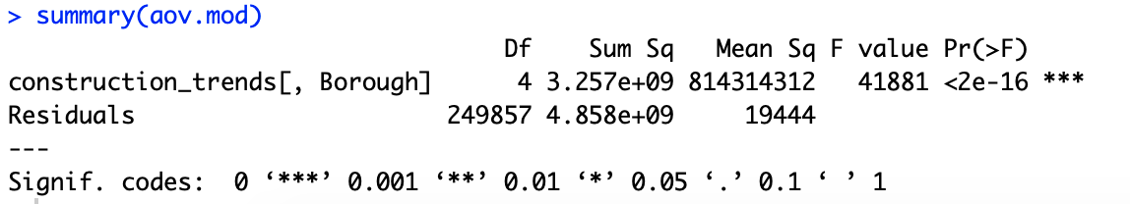

*Figure 3.1- ANOVA Output*

The low p-values lead us to accept the alternate hypothesis that there is a significant relationship between the number of buildings being constructed and the Boroughs. Similarly, a second ANOVA test was carried out to quantify the relationship between the number of Demolition type (‘DM’) jobs and the Borough. This, too, showed a significant relationship with a high F-value of 8007. To verify if the differences do exist between all Boroughs and that the test isn’t actually thrown off by a large variation in any one Borough, a post HOC test was performed. For this case, I have used the Tukey Post Hoc Test and, sure enough, the test confirmed a significant difference between each of the 5 Boroughs.

To study the correlation between the above constructions and the Air Quality, I first looked at the correlation between the Number of Construction and Demolition jobs and the Median Air Quality Index between the years 2000-2018. A negative correlation of -0.36 was a surprising result, since it was expected that an increase in construction would also lead to an increase in the AQI. The Annual Summaries of the Air Quality Index (AQI) data published by the U.S Environmental Protection Agency include the number of Good Days, or days with a healthy AQI, and the number of Unhealthy Days, or days with a low AQI value. A logistic regression model was fit with the proportions of Healthy to Unhealthy AQI days as the predictor variable, the output of which is shown in Figure 3.2. To fit the model details on the number of construction and demolition jobs, including the square feet and number of floors involved, were treated as predictors.

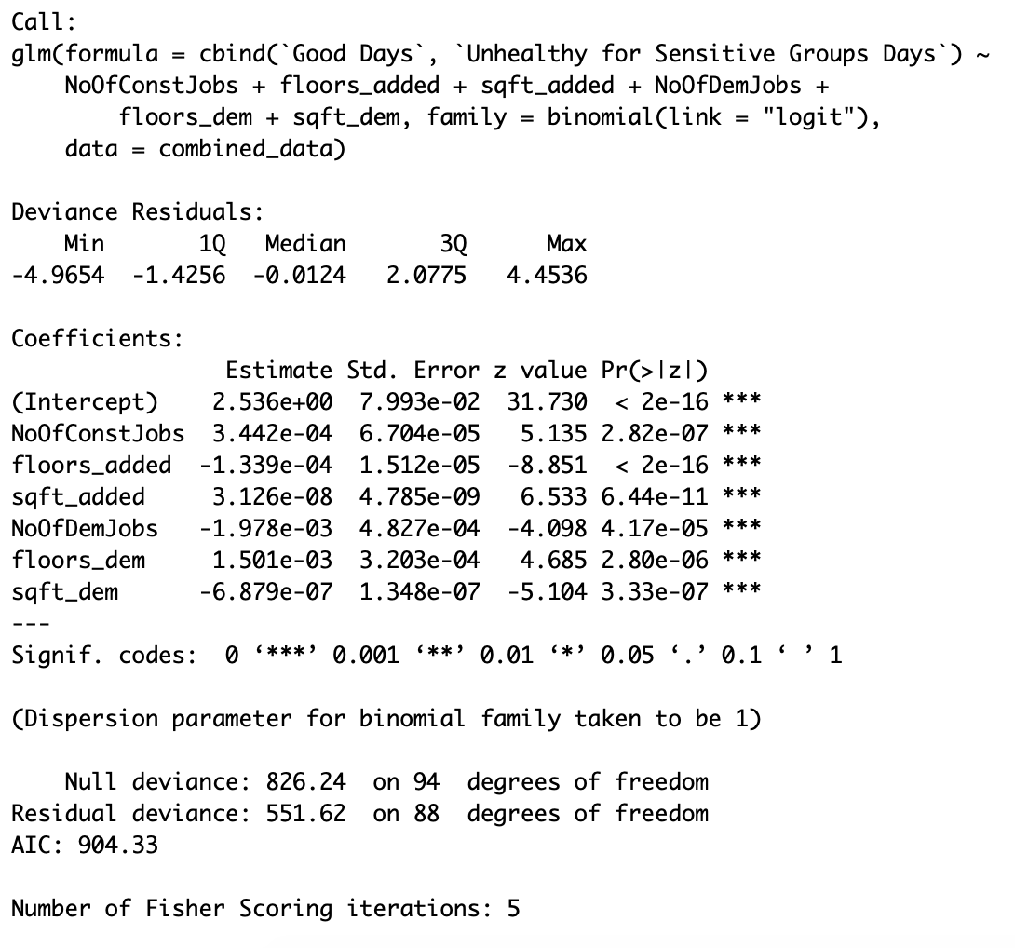

*Figure 3.2 – Logistic Regression Output*

The statistically significant, but positive, coefficient for the number of construction jobs goes against my intuition, since this would mean an increase in construction increases the likelihood, or log-likelihood to be precise, of a good AQI. The negative coefficient for the number of demolition jobs indicates the derogatory effect of building demolitions on the Air Quality.

## 3.3 Electricity Consumption

Since 2010, the population of New York has grown by 5.5% and the last 9 years alone account for almost 40% of major constructions (including New Buildings and Type I Alterations) in New York. Given this, it was surprising to see a 6.5% reduction in the electricity consumption in New York over the same time period.



*Figure 3.3*

In 2014, Governor Andrew M. Cuomo launched New York’s signature energy policy, Reforming the Energy Vision (REV). REV will build an integrated energy network able to harness the combined benefits of the central grid with clean, locally generated power. This program was launched with the intention to reduce the overall Electricity consumption in New York and as a result, achieve a 40% reduction in the greenhouse gas emissions from the 1990 levels. The reform also called for alterations in the Electricity setups in buildings and establishments across the city. Going back to our original dataset, it is found that the years 2014-2016 alone account for 47.3% of all electricity related jobs undertaken over the past decade. While the dataset does not mention a separate work type category for electricity related works, this information was obtained by parsing the Job description for electric works and repairs. The above results show a definite success in the REV program in New York City.

Another aspect that I considered was the installation of solar panels in buildings. Figure 3.4 shows the trends of jobs pertaining to the installation of solar panels filed with the DOB. Over the last decade, we can see an increasing number of Solar Panel installations across most of the city. Manhattan, surprisingly, seems to have negligible jobs of such description. This anomaly could be in correlation with the density of buildings in New York. I hypothesize that the dense and substantially taller buildings in Manhattan, as opposed to open spaces that Staten Island boasts, have led to the low-scale adoption of solar energy in Manhattan. However, I have not found the right data to back this assumption.



*Figure 3.4*

## Water Consumption

Like Electricity, New York has done a commendable job to ensure a reduction in its water consumption as well. Between 2013 – 2017, there has been a 27% reduction in the water consumed in the city. And just like with Electricity, this reduction can once again be attributed to the policies enforced by the city. Residential properties account for roughly 78% of the cities total water demand. To reduce this usage, the government had launched a series of schemes, one of which was the Toilet Replacement Program which was launched in July 2014. Unfortunately, no meaningful links were to these results were found in the Permits Issuance dataset.

# Conclusion

The study involved a statistical analysis of the permit issuance dataset in the city of New York, with a focus on the Environmental Implications of urbanization and the construction work that comes with it. Underlying patterns in the dataset, specifically the temporal and spatial variations of the permits were identified. It was also concluded that the permit dataset provides a reasonable estimation of the trends with the overall population in New York. This result was exploited later on while studying the environmental impacts of the construction works in the city. First, the construction and demolition activities were studied for their plausible impact on the Air Quality Index. While such a causal relation cannot be confirmed, owing to the numerous other influencing factors, it was still surprising to see that construction jobs were associated with an improvement in the overall air quality. Demolition jobs pointed towards a reduction in the air quality. Next, electricity and water consumptions in the city were studied and were found to have reduced over the years, despite the steep increase in population. Government policies were identified that could have caused this reduction in consumption. For reduction in electricity use, an interesting correlation between Electrical job permits and the reduction in consumption for found. Unfortunately, no such relationship was obvious when it came to water consumption. Even so, New York has identified itself as a fine example for other cities to follow. Despite being one of the most densely populated cities in the world, it has adopted policies to curb the environmental impacts, the proof for which was seen in the study.

# Appendix

1. Code:

*https://github.com/pranavlal30/NewYork_Permits.git*

1. Permit Issuance Dataset:

*https://data.cityofnewyork.us/Housing-Development/DOB-Permit-Issuance/ipu4-2q9a*

1. Job Application Filings Dataset:

*https://data.cityofnewyork.us/Housing-Development/DOB-Job-Application-Filings/ic3t-wcy2*

1. Air Quality Measures:

*https://www.epa.gov/outdoor-air-quality-data*

1. Electricity Consumption and Cost:

*https://data.cityofnewyork.us/Housing-Development/Electric-Consumption-And-Cost-2010-June-2018-/jr24-e7cr*

1. Water Consumption and Cost:

*https://data.cityofnewyork.us/Housing-Development/Water-Consumption-And-Cost-2013-June-2018-/66be-66yr*